**Tugas Week 11 IS 429 Big data Christopher Darren – 00000054804**

**A. Get the Data**

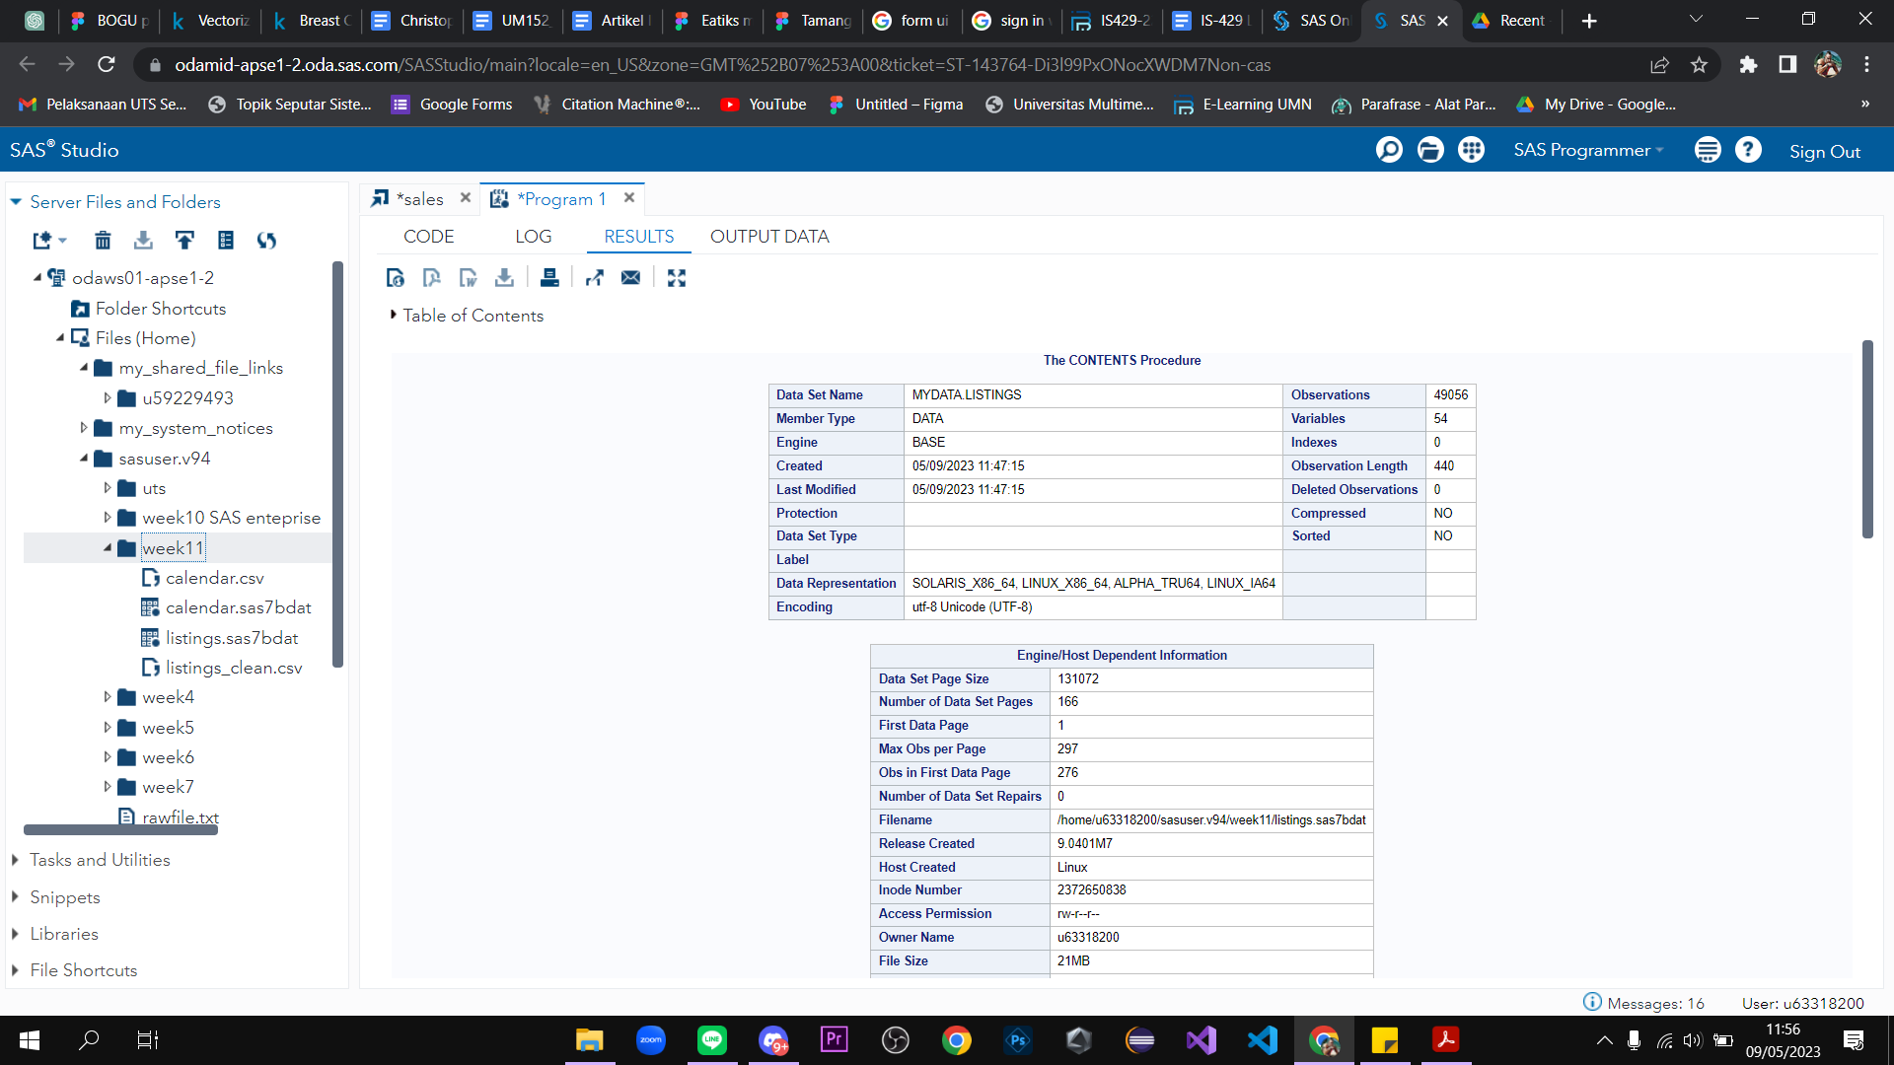

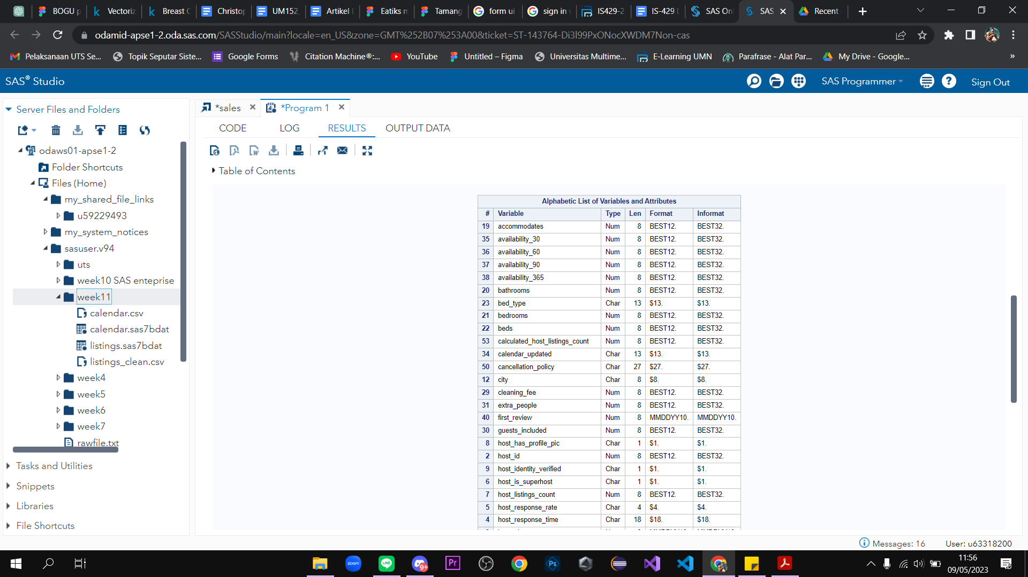

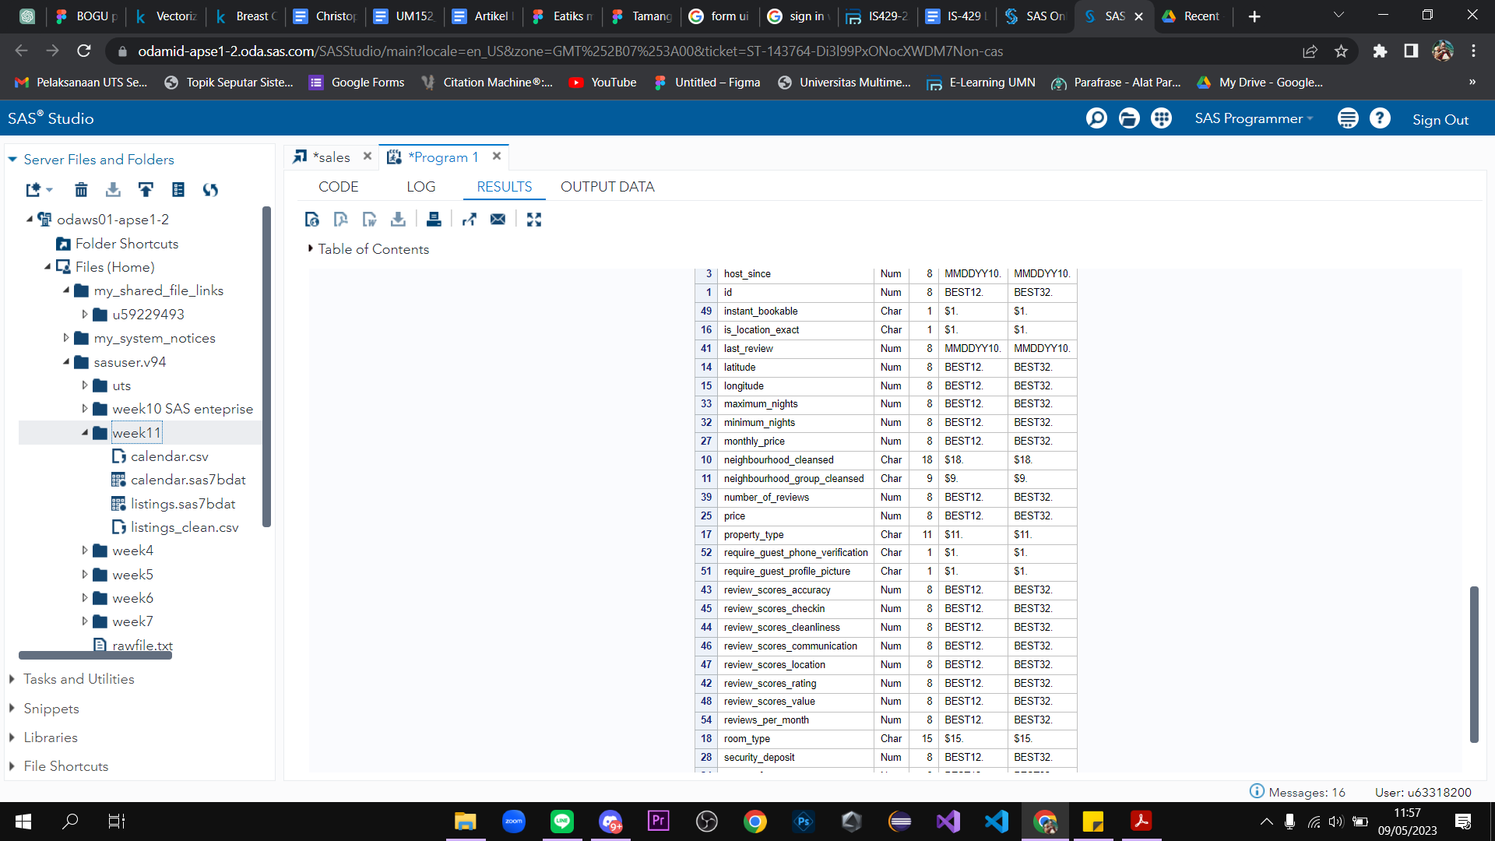

**B. Create Geographic Map**

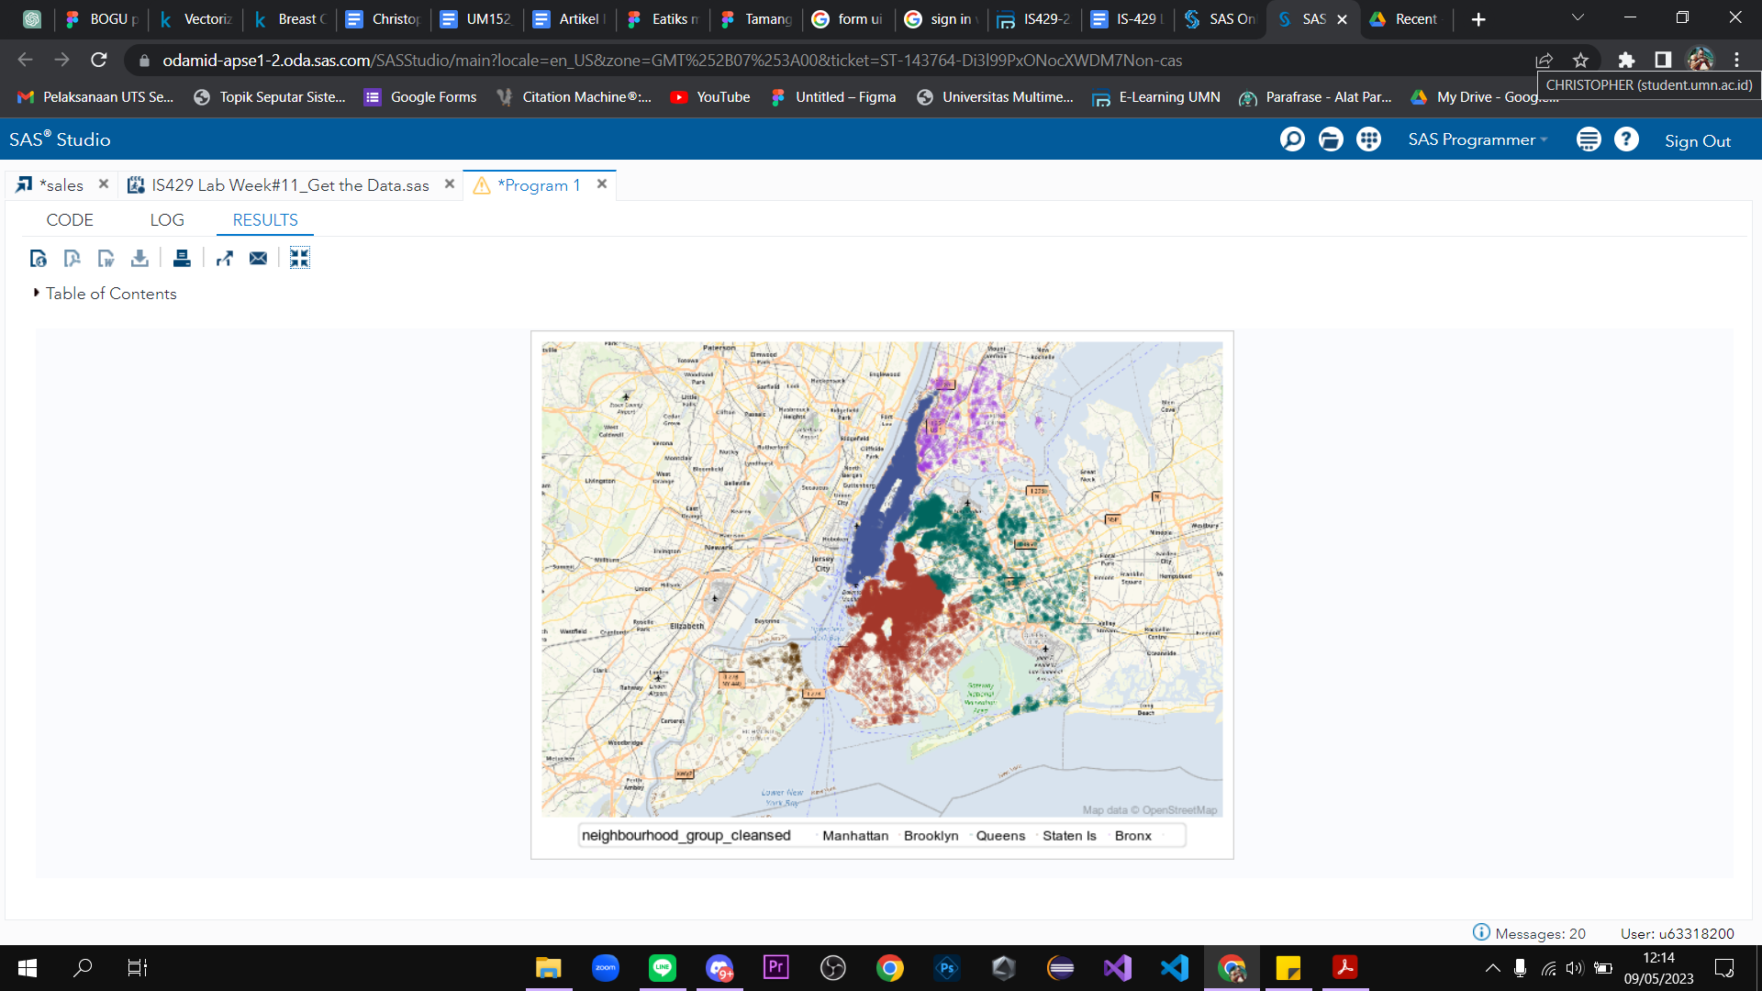

**C. Exploring data files**

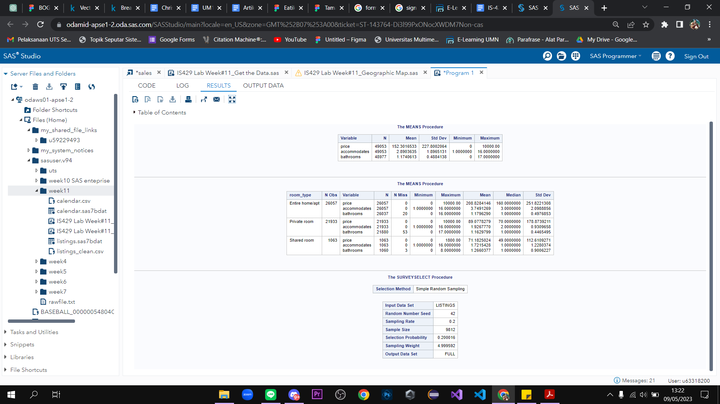

**D. Explore the target variable**

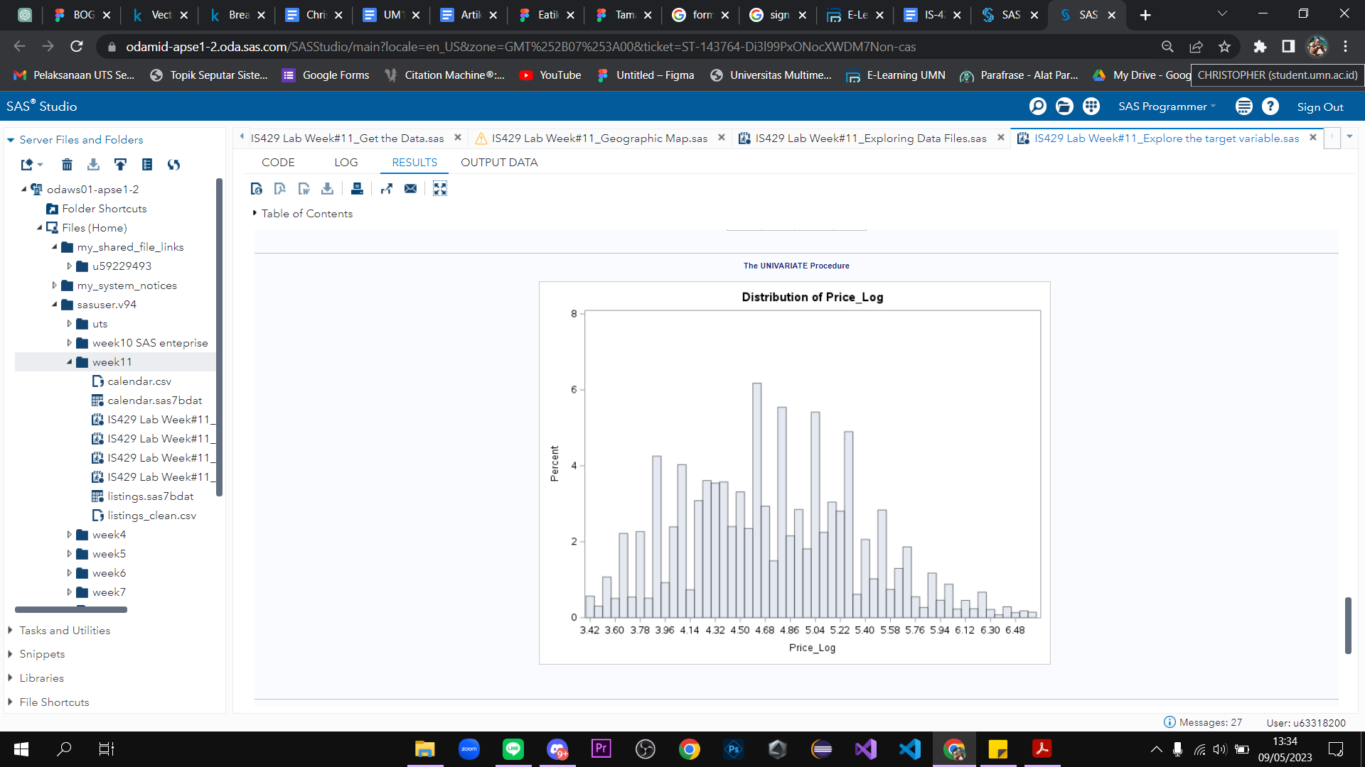

**E. Predictor Variable Analysis**

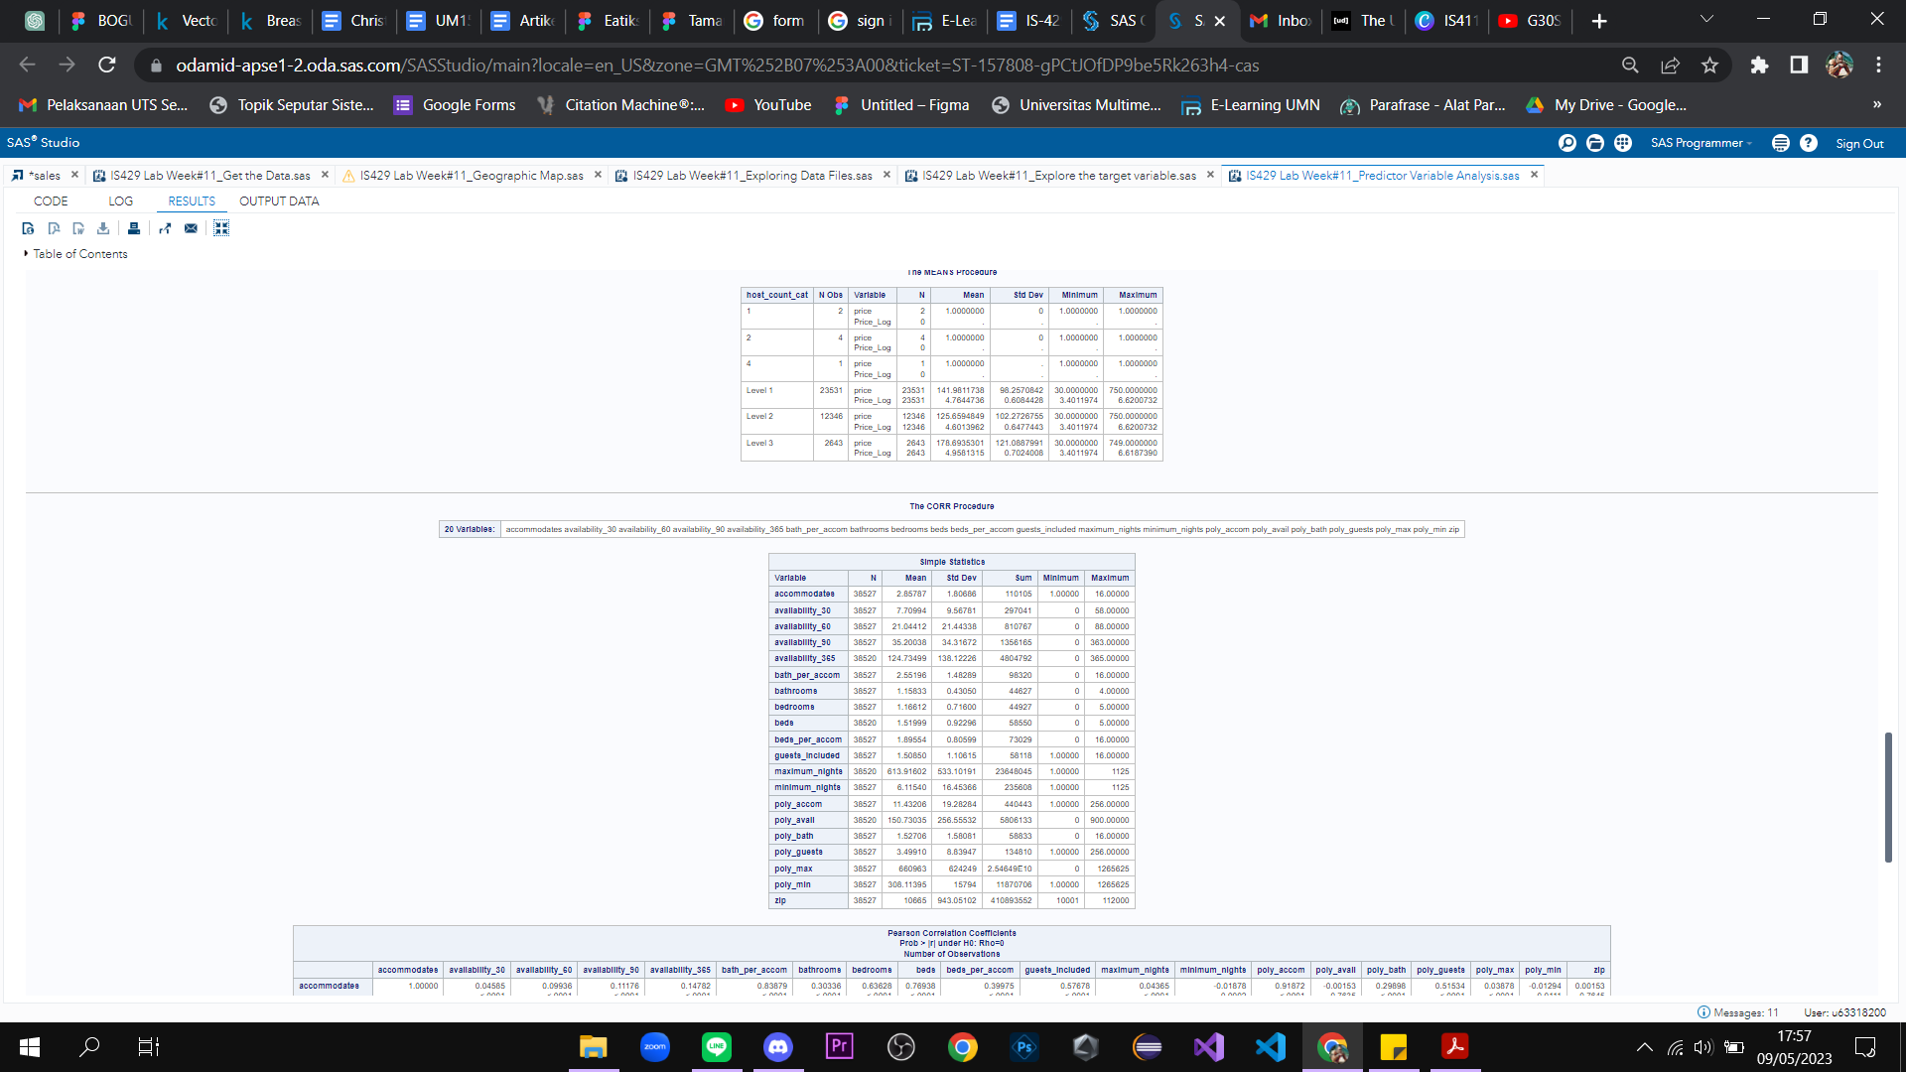

**F. Scatter Matrix**

